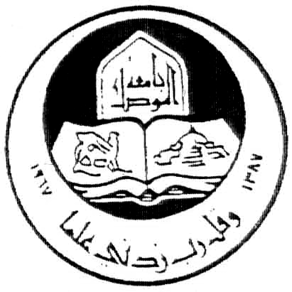
University of Mosul
College of Education

Yet and But in Holy Qura'an Consistencies and Denotations

A Thesis Submitted by
Tamara Natiq Tahir

Master Degree
Qura'a Sciences and Islamic Education

Supervised by
Assist. Prof.
Dr. Zahida Abdullah M.

2008 A.D. 1429 A.H.

