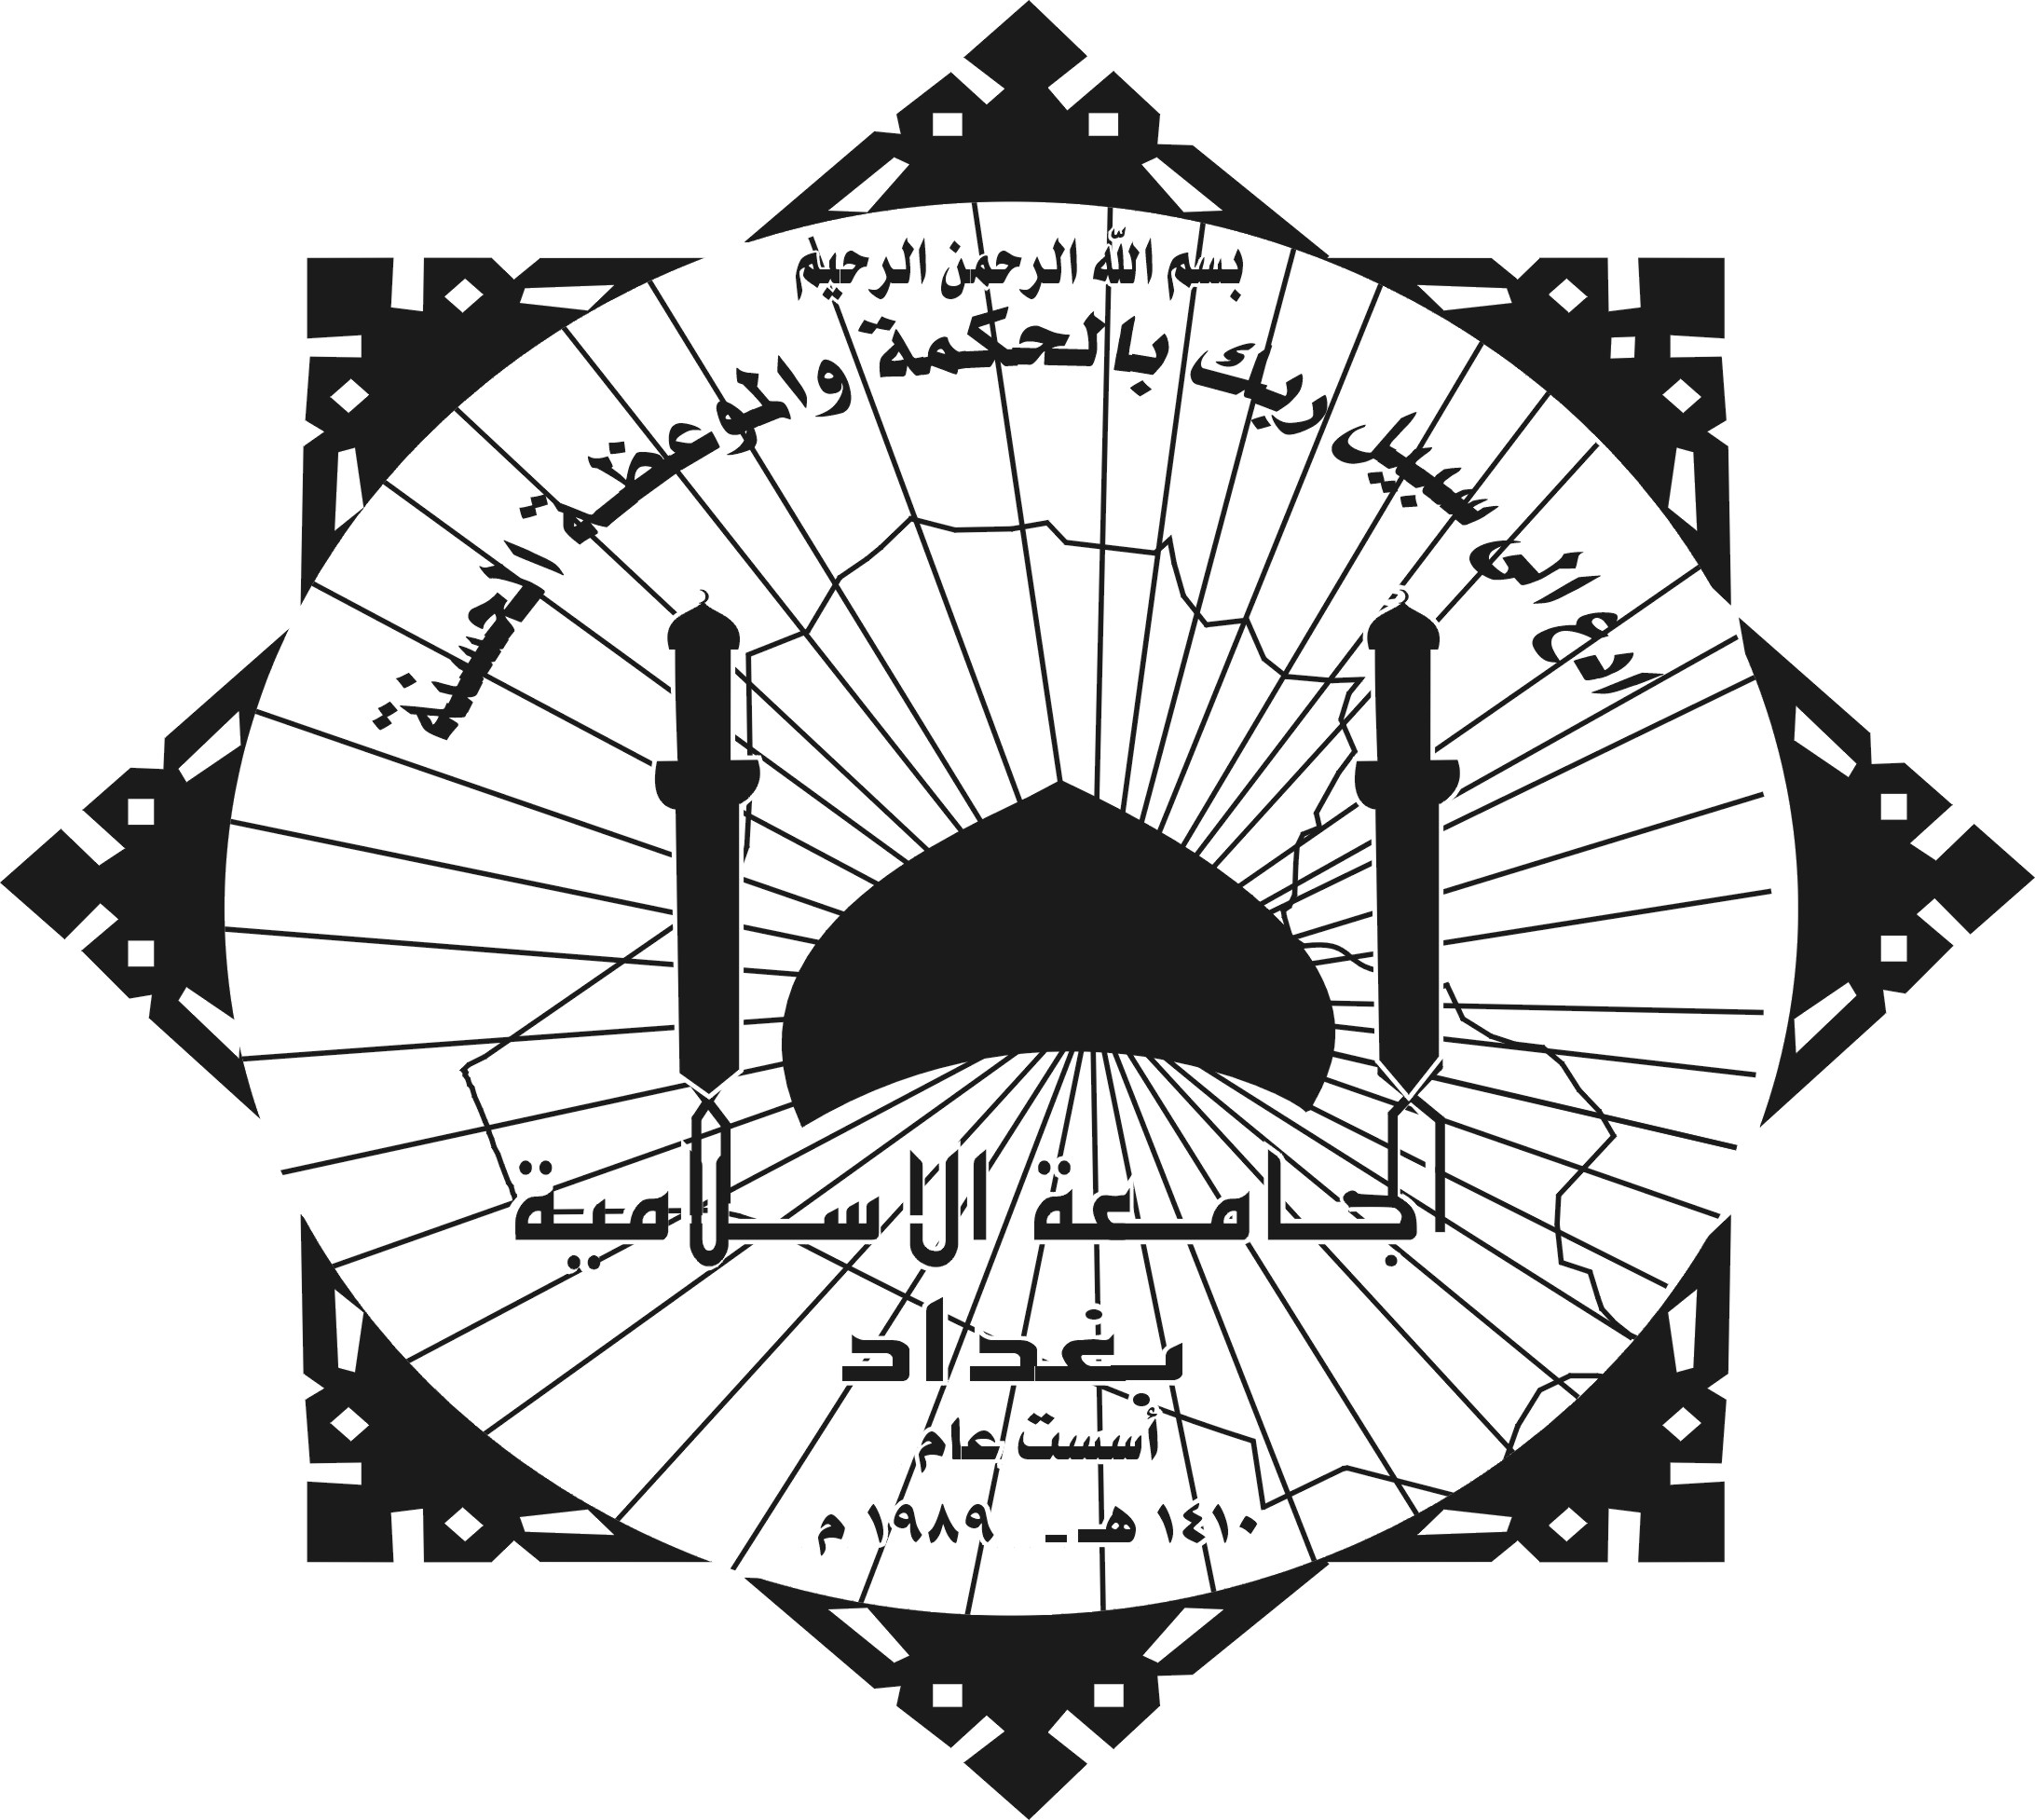

Ministry of higher education and scientific research
The Islamic University – Baghdad
College of arts

The Concept of ( Al ahal and Alaal)
In the Holy Quran

Subjective , illustrative study thesis submitted
Ahmed Ali Nimmah Al. Zubeidi

to the council of arts college
as a partial requirements of wining M.A degree

in
The Holy Quran studies specialization (Interpretation)

Supervised by
Dr. Ammar Abdul Kareem Al. Jaffery

1428 A.H 2007 A.D

