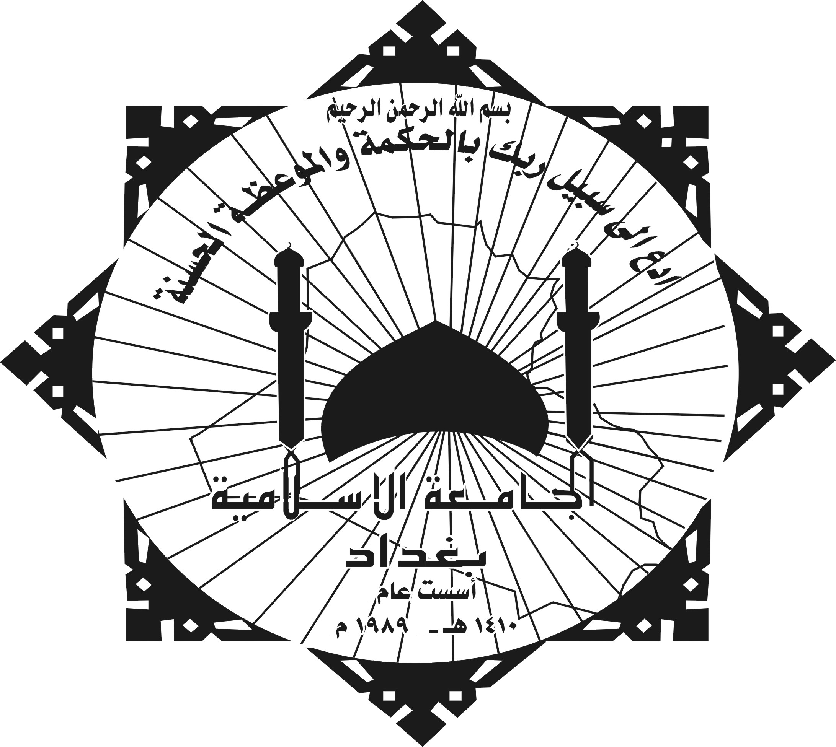

The Islamic University- Baghdad
College of Arts

Lie in the light of holy qur'an verses

A Thesis Submitted By:
Abdul- Qader Aiash M. Al-Saamaraai

to:
The council of college of Arts at Islamic University
In Partial Fulfillment of the requirements of Master degree in Qur'an Science

Supervised by:
Dr. Muhammad Shaker Alkubaisi

1427 A.H. | 2006A.D.

