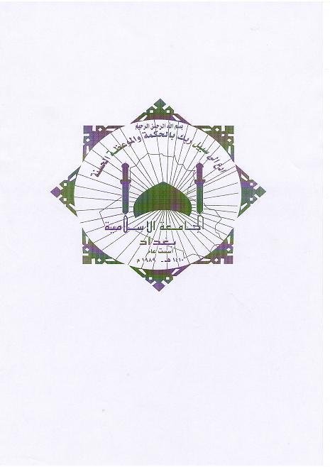

Ministry of Higher Education and Scientific Research
Islamic University - Baghdad
Faculty of Arts - Department of Science Quran
Graduate Studies

Quranic sciences in the six books
The collection and study
Thesis submitted to the Board of the Faculty of Arts
Science Quran - Islamic University
It is part of the requirements of Ph.D. in Quranic sciences
Introduction by the student
Abdel-Aziz Abdel- Aziz al-Rawi
Under the supervision of Prof. Dr.
Abdullah Hassan Al hadethe
2010 1431

Ministry of Higher Education and Scientific Research
Islamic University - Baghdad
Faculty of Arts - Department of Science Quran
Graduate Studies

Quranic sciences in the six books
The collection and study
Thesis submitted to the Board of the Faculty of Arts
Science Quran - Islamic University
It is part of the requirements of Ph.D. in Quranic sciences
Introduction by the student
Abdel-Aziz Abdel- Aziz al-Rawi
Under the supervision of Prof. Dr.
Abdullah Hassan Al hadethe
2010 1431

